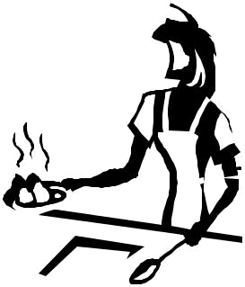
Nancy Olusegun

7, Alade Avenue~ Ikeja, Lagos 99000
(234) 555-5555
nolusegun@myjobmag.com

PR O F I L E

- Results-oriented, dedicated professional with extensive experience in the restaurant and hospitality industries.
- Outstanding customer service skills with proven success in managing multiple priorities simultaneously in fast-paced environments.
- Outgoing, optimistic employee with the ability to get along well with everyone.
- Solid supervisory, mathematical and planning skills.
- Recognized by patrons for providing courteous, efficient service and ensuring positive dining experiences; consistently achieved a following of “regular” customers.

EX P E R I E N C E
HUNTER’S CAFE, Soldotna, Alaska |  | 1996–2003
Head Waitress

- Promoted to position for consistently demonstrating ability to manage high customer volume successfully during peak periods.
- Supervised wait staff of 11 and completed weekly schedule to ensure appropriate coverage.
- Hired, trained and guided new employees in restaurant operations.
- Ordered supplies and confirmed adequate inventories.
- Achieved overall accuracy rate of 98% in reconciliation of daily receipts.

ALLAGASH GUIDE SERVICE, Allagash, Maine | 1985–1996
Co-owner

- Co-founded and managed a successful hunting and fishing guide service for avid sportsmen.

- Gained recognition as a first-rate service for big game hunters and fishing enthusiasts.
- Prepared, planned and provided meal and rooming accommodations.
- Conducted canoe transports and guided deer hunts.
- Commended and received bonuses from customers for outstanding service.

BEACH INN RESTAURANT, Lincolnville, Maine | 1991–1996
Head Waitress

- Greeted customers; took food and beverage orders for seasonal clientele.

- Prepared tables and dining area for service; coordinated room arrangements for large parties.
- Provided prompt, friendly service and completed daily cash reconciliations.
- Updated menus with daily specials; advised kitchen staff on special dietary requests.

Let us help you move to the next level with our professional CV writing services.
Click here, for your CV rewrite service

